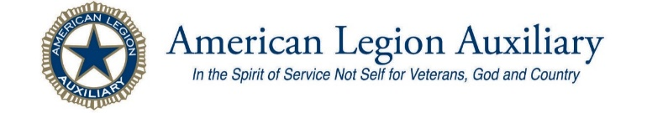
FOURTH DISTRICT NOVEMBER NEWSLETTER
Auxiliary Members of the district hope you will not have too much trouble adjusting to the time change.
Be sure to mark your calendars with the events that are going on this month. The Marine Corps Birthday, Veterans Day Programs (If CDC and DOH) mandates will allow them. A must to place on your calendar for Monday 30 Nov is the Gift Shop setup at Post # 2, 11204 112th Ave and Layfette just off 112^{th.}
In last month’s Newsletter I mentioned that Gift Shop would be different than in the past. First off as you can see the location is not at American Lake VAMC; this is due to the restrictions imposed by the Department of Veterans Affairs regarding volunteers and visitors on campus. This has caused several members to turn on their Critical Thinking Skills as to How we in the American Legion Auxiliary can adapt to those restrictions and still provide a service for a hospitalized veterans.
Location: Changed to permit volunteers assist with gift selection and shopping.
Day and time: Remain as close to normal as possible; set up Monday, following Thanksgiving but NO High Tea, shop for veterans begins after lunch.
Gift Selection: More than likely will be remotely done via photo book or actual video of the gifts.
Wrappers: MUST wear your mask, bring a sweater or jacket, as the location can cool off quickly, have your comfortable shoes on.
You will be placing items on tables and or wrapping the selected gifts in Christmas paper then boxing those gifts into overpack boxes for mailing to the family members and then wrapping in brown paper for the USPS mailing.
Worker Limitation: on number of persons in each of the designated work areas. Signs will be posted in each area.
VAMC American Lake Christmas Gift Shop
30 November to 2 December 9am to 4pm
At Edward B. Rhodes Post 0002
Menu ideas
Monday: Pizza will be provided for volunteers
Tuesday: Beef Chili and Vegetarian Lentil soup
Wednesday: Chicken Soup and Veggie Chowder
Please contact Debbie Donaldson for more
Information on when you can volunteer. Please remember that we MUST follow Pierce County Health mandates for COVID-19 restrictions:
Debbie’s phone: 360 688 3821 or e mail her at
westy22dc@gmail.com

Orting 3 Dec 2018 Gifts, gifts, and more gifts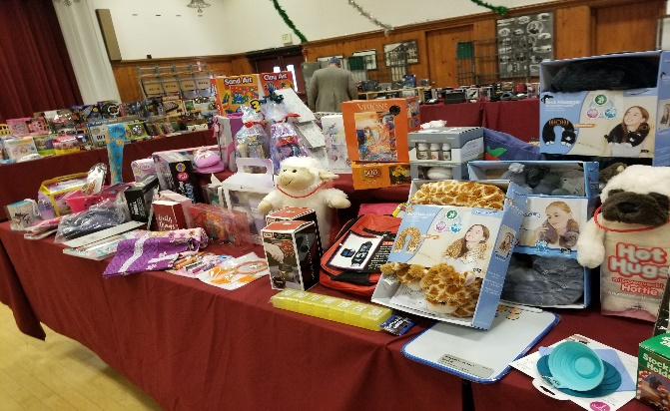
Unit 2 Jennifer K
Happy
Birthday
To all the
November
Ladies and Gentlemen who are
Celebrating
this month

Karen L
Mary Mc
Shirley W
Unit 3 Kerri B
Lindsey B
Ginny C
Bonnie C
Tamela G
Judy H
Terri H
Hailey K
Unit 53 Barbara L
Unit 94 Katherine N, Marti K
Unit 138 Melodie F
Unit 187 Frankie D, Rose Marie D, Molly M
Unit 264 Ruby H-S, Violet H-S, Loren J
Unit 265 Megan A, Alana I, Kristen K, Mary R
Again, I apologize if you have a November Birthday and your name is not within this list, this is because your DOB was not in National’s data base.
Veteran Affair and
Rehabilitation
Department’s VA & R
Representative is
looking for a way to
provide a gift to the clients living in the CLC the
Community Living Center at American Lake. Debby Ramirez wants to know if your unit would like to partner with or challenge another Unit in the district to purchase items such as slipper socks, crew socks, Word Search puzzle books, Find the hidden objects books, 100piece puzzles, and Body Spray for men. At present there is only one (1) female at the CLC. Candies individually wrapped are always appreciated, both Sugar Free and regular candies.
Sick Call and Recovery

I have not received any calls this past month regarding members who have gotten sick or injured . With that being said, I ask that you check on your members through out the month if your unit is or is not meeting to see that they are doing well.
I ask that all of you continue to say a prayer or two for all the Auxiliary members that might be or have relatives in the Gulf Coast area, California, Colorado and the areas affected by Tropical Storms, multiple Hurricanes, wild fires and those without power due to these and other Natural Disasters.
Unit Presidents please bring up the topic of making a Unit Donation to the AEF Auxiliary Emergency Fund at the National level, to help other Auxiliary members who may have lost their homes as well as all the contents contained therein.
MEMBERSHIP

The first round of membership prizes for reaching the benchmark set by National will be on 11 Nov 20.
There are several Units in the Department that have reached 100%. According to the Membership status there are several more that are getting very, close to reaching that 100% level. Mind you some of these are units with more than 100 members. To them we should tip our hats and provide a congratulatory WHOOOah!! We in the 4th District just need to work a bit harder at reaching out to members and getting them to turn in their due’s payments before 31 Dec each year.
Unit membership chair and treasurer Important reminders regarding the processing of the payment of dues; 1) Members get their cards immediately if paid at a meeting, 2) The card is mailed to the member within 48 hours if mailed in to the Unit.
3) Dues payments are deposited into the Unit bank before the 15th day. In other words, do not hold on to checks. 4) Get your transmittals into Shelli S our Department Secretary, so that membership can be placed into ALAMIS as quickly as possible. 5) Make sure to fill out transmittals correctly,
alphabetically by last name, if you have a change of name, change of address, or change of status (i.e.: going from Jr. to Sr.) a Member Data Form is sent along with that transmittal. Keep copies of both the Transmittals and Member Data Forms. The responsibility lies with the Unit not Department to maintain accurate records!
Vice President Karen Grundler is your point of contact to answer questions regarding member-
ship. Provide a New Member Packet to each new member recruited. Offer the member a Unit Guidebook to help them understand our programs, the benefits of membership and the fulfillment of service to the local veterans and military and to their families. I ask that you also provide information on Scholarships for those that have children in Middle and High School. Please remember to mention the Constitutional Speech contest as well as Girls and Boys State programs. We want to treat all members with courtesy, and respect, acts of civility, social graces, always the golden rules.
Committee Chairman for Auxiliary Emergency Fund has been filled!
Reina Allen has volunteered to step up to take this chairmanship. She will be mentored on filling out and filing of the forms, writing the Narrative that goes to the NEC meeting and then to the ALA AEF Foundation for review and there the final decision to provide the grant and the what amount of the $2,500.00 will be given to the member. Outstanding bills will be paid by the foundation on the members behalf.
Thank You Reina for taking this on, I will be there by your side until you are comfortable and confident in processing requests. Thank You!

The District Education Chairmanship still needs a strong person to head this committee. You will work with Schools in the district and chairman of the Americanism, Poppy and Girls State programs as there are scholarships available at various levels for Americanism and Poppy programs. Young ladies who apply and attend Evergreen Girls State could apply for one or more of the Scholarship, each of the scholarship is for a specific field of endeavor, Nursing, Fine Arts, General Studies. You will be working with the Department Education Chairman Jane Montaney, she has a wealth of knowledge and is willing to assist any of the District chairman when asked.

I need your help in making this newsletter more
Informative on a level where your unit information is included. I know that Unit 53 of DuPont does a Legion Family Newsletter, Unit 3 of Olympia also

does a newsletter and post’s it on their Web page.
To place your Unit’s upcoming events into the District Newsletter just drop me an email with the
Date, time, location, cost, and cause or service that you will be providing or sponsoring. Sponsoring Wreaths across America, Assisting with a Veteran job fair. Most of you have the email address, just in case not It is: army91c72y92r@gmail.com
There is plenty of space that can be utilized for a recipe or two, a TRIVIA section and beginning in January you will have to look closely to see if you can locate the membership number that will be located within the Newsletter. I have not yet determined if there will be a prize for the member of the person who spots the number. So, stay alert for that information as well in December’s edition.
I have a preference and commitment to the 11 Unit Presidents to get the newsletter out as soon after the District Meeting or Council Luncheon as possible, so Information is disseminated to Unit members at their monthly Unit meetings.
Deadline for sending me information will be the Friday before the District Meeting.

As you can see the position of Secretary and District Sgt-at-Arms remain open:

District President Catherine A. Olson
Email: army91c72y92r@gmail.com
Cell: 360*239*6383
District Vice President Karen Grundler
Email: grundler1@comcast.net
Phone 360*412*4017
District Secretary VACANT
District Treasurer Theresa Kistler
Email: theresa_kistler@yahoo.com
Cell: 360*561*7237
District Chaplain Karen Lebeter
Email: klebeter@msn.com
Phone: 253*579*7768
District Sgt-at-Arms VACANT

Requirements: Secretary will record and transcribe minutes of the District’s monthly meetings, Spring Conference and District Workshop. Assist the Chaplain with the program for the District Spring Conference Memorial. Read Correspondence at meetings and prepare correspondence as directed with the District President. Submit request to the Department Secretary for a visit from the President of the Department of Washington, or any National Officer that will be visiting the State in her tour of the country. Notify the District President within 48hrs of your inability to make meeting(s).
Sgt-at-Arms is responsible for maintenance of the District Colors and flag stands. Learning the procedure for the Aisle of Flags, Memorials for departed Auxiliary members, escorting Department and National officers as well as civilian dignitaries to either a place of Honor or Seat at the Head Table. You and the Legion District Sgt-at Arms will train 2 Color Bearers on the proper manner to present and retire the colors from a hall. Be available when District Auxiliary will be represented at Legion functions having Auxiliary Colors and stands present. Upon closure of the event, make sure that National Colors and Auxiliary Banner are secured in their case and Stands are also present.
Be willing and able to participate in Public Events, Parades, Department Functions excreta.
Notify the District President within 48hrs your inability to make meeting(s).

Catherine A. Olson
Catherine A. Olson
Fourth District President
American Legion Auxiliary
Department of Washington
360*239*6383

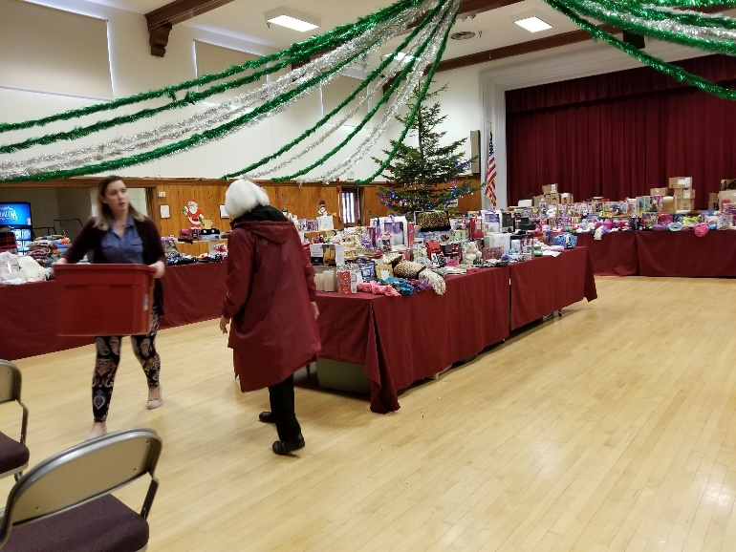
Ladies from Unit 138 Judy and Katrina at Orting 2017 Gift Shop just before lunch break.
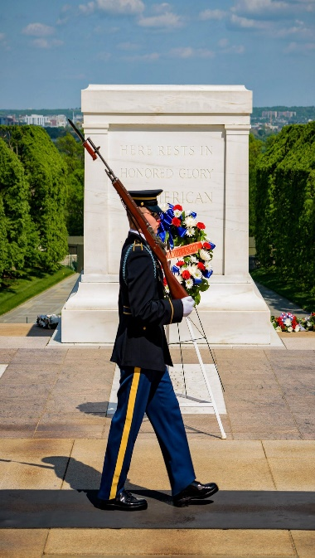
REMEMBER TO HONOR
ALL THOSE WHO HAVE SERVED TO PROTECT AND DEFEND THE
CONSTITUTION OF THE UNITED STATES OF AMERICA.
WE CONTINUE TO LIVE BY THE OATH OF ENLISTMENT UNTIL WE CAN NO LONGER TAKE A BREATH. THANK YOU TO ALL MY BROTHERS AND SISTERS.

