FOURTH DISTRICT NEWLETTER AUGUST 2020
FOURTH DISTRICT NEWSLETTER AUGUST 2020
Ladies:

I realize that it has only been a few weeks since the July letter was sent out but I want to make sure as the period of “Stay Home – Stay Safe” continues to shade the calendar squares with more days of not seeing our Legion Family, it’s imperative provide you with positive, informative and helpful information.
MEMBERSHIP INFORMATION

Department Secretary Shelli has begun mailing your membership cards to the updated addresses that you provided for the Unit Membership person, Unit Secretary or Unit President. If you told her same as last year you need to call her or e-mail her provide an up to date correction/confirmation as to the address where cards will be mailed to.
For the past four years when the cards have arrived from National, they were mailed to the address provided the previous year. Thank goodness that is not the case in our district as much as it was in several other districts.
For members with e-mails noted on your original application you need to check your SPAM or JUNK FOLDER to see if you received a notice. If no notice via email you can still pay your dues either to the unit or go online at: alaforveterans.org/members. You’ll find the renew online under either one of these of tabs “join us or contact us”, you have done so you need to print out the receipt and show that to the unit membership chairman so she/he can add you to the next transmittal to be submitted with PAID ON LINE NOTED next to your name otherwise you will not show paid on the Unit roster when it is printed. Your card will be mailed to you from National in approx. 7 to 10 days.
REPORTABLE NEWS

UNFINISHED BUSINESS: The Owl Family that was raffled off was won by Selah Unit #88. They were given the choice of the Owl Family or $50.00. The ladies from Selah decided to take the $50.00, then told Jane Montaney the Raffle chairman they were donating the winnings back to the President’s Project of the National Creative Arts Festival.
A significant amount of money is needed to provide the visiting artists, their family member(s), Caregivers, and ALA State representatives a Hospitality/Rest and changing area for the National Creative Arts Festival coming to Washington State in the future. The National Festival runs for 7 to 10 days and has multiple levels and categories for participants to go through. Past Department President Jane will be providing a report on the results of the raffle.
CORRECTED INFORMATION
:

COUNCIL LUNCHES:
OCTOBER 5, 2020 HOSTED BY Unit 94; 2602 Marvin Road SE Lacey. Social 11 Meal 1130 Mtg: 1230.
Update the January Past District President’s luncheon will be at Mt. Tacoma Unit 0148 the First Monday 4 January 2021. Notice to be sent out later.
SICK CALL & RELIEF and UNIT EVERLASTING

COMMUNICATION between you, the District Chaplain or myself regarding notification of illness or death of a unit member is really important to keep those members in the district informed, so cards of “Get Well Wishes” or “Thinking of You” can be mailed to the person so the message may brighten their day and speed recovery. “Sympathy or Condolence” Cards are so important to let the family know we are acknowledging the loss of a dear friend as they mourn the loss of a spouse, parent, sibling, or child.
Sending a card is such a small gesture of kindness yet it can brighten the spirits of a member who is feeling blue, depressed, or melancholy. KEEP THOSE FOLKS IN MIND AND KEEP IN TOUCH with them so they remain in contact with you.
I have spoken to two ladies while writing this newsletter. Just a quick call to ask how they are doing and let them know that you are willing to help shop for groceries, if you are able, or drive them to a doctor appointment again if you are able.
I am asking you to send a get-well card to Melodie Foster, as she had surgery in July and has been in rehabilitation since about the 24th of the month. Send cards to 3223 S Durango St. Tacoma, WA 98409. Would you send a card of support “Thinking of you” to Lew also? This is the longest that he and Melodie have been separated since he served in the military.
Auxiliary members are like a second or third cousins, family from a different mother, if that makes sense?
E-PACKET INFORMATION

Unit President’s and Secretaries please check the e-mails sent to you by the Department Secretary, these contain information you should be aware of and pass on to your members. She sends the information to assist you with the day to day operations of your unit. Information regarding Auxiliary programs as provided by National Headquarters.
Congratulations CCCCONGRATULATIONS

Units that have made or surpassed goal are:
This Photo by Unknown Author is licensed under CC BY
Anderson Island Unit 265: Lakewood Unit 187: Eatonville Unit 148: Lacey Unit 0094; Puyallup Unit 0067 and Olympia Unit 0003.
Additionally, Units 264 of Rainier, 2 of Tacoma, 138 of University Place were so close needing only 2 to 3 more to renew or join to make the 100%.
All the units within the district worked at hard building membership and I appreciate all the time and efforts you put forth in helping not only the district place high in the ranking but you helped the State rating as well. In 2018 we were at 47th of 53 on the National rating, this year we move to the top third of the departments
at National. THANK YOU!
Regarding your membership Unit President’s please check with your Membership chairman or your Secretary to see if you have members with 5, 10, all the way to 80 years in 5-year increments in the Auxiliary. One way to assist with retaining our members is to HONOR them for their years of Continuous Membership with a certificate. If you do not have access to ALA-MIS to get a complete Unit Roster with your members join date the district vice president and I can assist you with that. All you must do is ask and I will have your roster at the October Council Luncheon.
Submit a list of your members to Shelli our Department Secretary with their date of entry, # of continuous years. I found it easiest to group the members by years so that Shelli knows how many certificates to send or to order for you. She will also verify the accuracy of the years for National on the order form she submits.
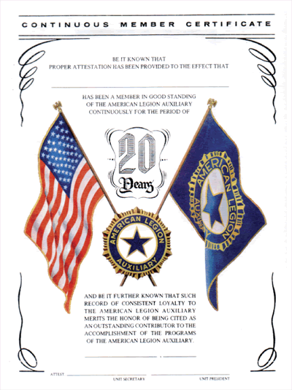
Each Certificate will arrive on Card stock 8.5x11 and cost $1.00. There are a limited number of 9x12 certificates left and those also cost $1.00. There are several choices that you have is to give certificates every five years a members maintains continuous membership or you can purchase a guard that attaches to the membership pin, these are more expensive at $8.95 each, but look nice and members wear the guard proudly.
Certificate of Appreciation, Certificates of Participation and Meritorious Service are also available for you to reward and honor your members, their volunteerism, promotion of the Auxiliary Programs. The cost for these is also in the $1.00 to $1.50 range. You can order these certificates on your own by going to: emblem@legion.org look under the Auxiliary for any and all your needs.

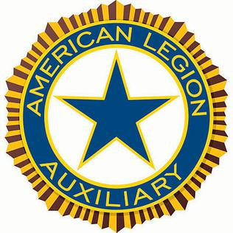
FOURTH DISTRICT OFFICERS MEETING

FOURTH DISRTICT OFFICERS MEETING NOTES:
Friday 31 July District Commander Gray Walker, myself, District Vice Commander Jim Cook, District Service Office, Auxiliary District Treasurer, and a few others met to discuss the upcoming Legion year; What will this look like? When will be able to meet in person again? and What has this pandemic done to our District Posts and Units? Is this going to hurt our ability to keep members interested in coming to meetings? Are Posts and Units going to do teleconferencing, Zoom meetings, or in person?
The Department Adjutant will be setting dates for the District Fall Conferences and Area Workshops. The Spring Conferences will be set up at Mid-Winter in February. Once those are known we, the district commander and I will finalize the plan for the district and ensure you are notified immediately.
For the Good of the Order
Unit 0003 Olympia is once again taking household items, small appliances, coffee makers, roasting pans, electric fry pans, waffle makers, dishes, glass ware, flatware, towels, clothing, serviceable shoes, and jewelry as our Fundraiser for Tuition for Girls State delegates.

Target date is NOV ____, 2020. EXAMPLES below

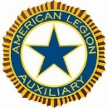District Officers 2020 – 2021

President Catherine A. Olson Unit 3
Cell 360-239-6383 (USE FIRST)
Home 360-438-3438
Email: army91c72y92r@gmail.com

Vice President Karen Grundler Unit 94
Home 360-412-4017
Email: grundler1@comcast.net

District Secretary
VACANT

District Treasurer Theresa Kistler Unit 3
Cell:
Home: 360-943-8426
Email: theresa_kistler@yahoo.com

District Chaplain Karen Lebeter Unit 2
Cell 253-597-7768
P.O. Box 3489 Ocean Shores 98569-3489
Email: lebeterk@gmail.com

COMMITTEE CHAIRS
AEF…………………………………. Catherine Olson
Americanism……………………. Vacant
Community Service…………. Vacant
Girls State…………………………Melodie Foster
Legislative…………………………Karen Lebeter
National Security………………Karen Lebeter
Past President’s Parley…….
Poppies……………………………. Karen Schwartz
*******DEPT. APPOINTMENTS********
VA & R………………………………Debby Ramirez
American Lake GS………. Debbie Donaldson
WDVA Soldiers Home……Melodie Foster
Orting Gift Shop…………. Melodie Foster

