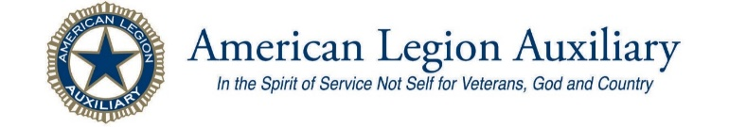
Alfred Wm. Leach Unit 0003
Newsletter: August 2020

Dear Unit members;
Hopefully this finds all of you doing well mentally and physically during this pandemic. I like many others have said prayers daily that each of you remains in good health and none of you contract this virus.
With the “Stay Home Stay Safe” mandate or recommendation from the Health officials as well as the governor’s office, y’all must have the cleanest garden beds in the county, or are craft projects cluttering up the family room, den or dining room table. I myself have been moving 12 years of Auxiliary records out of my house to the Auxiliary office at the Post home. Putting the mountain of stuff into easy to locate binders by decades. Teri Kistler and I have been at this project for a while, we have made progress but we have a long way to go to say the project is complete.
One of the things that was discovered is very few of you have been recognized for your time in the Auxiliary. So, I began going threw membership files and I have already sent out “Certificates of Longevity” to members with greater than 5 years in the organization. I am proud to inform you that we have one member who has 77yrs in the Auxiliary. She joined most likely with her mother at age 9 or 10 in 1944 under her father’s or grandfather’s time in service. We have three members who were joined in the mid-1950’s and have 64 or 65 years. This is a remarkable milestone and these women need to be commended for their dedication and devotion to seeing that our military of today are provided good treatment and respect they deserve for protecting our country from enemies both foreign and domestic, honor is shown to our veterans from all wars. These women also supply support to the families that remain here stateside as well as those that live overseas. Congratulations Ladies!
History Trivia ~ 100yrs of suffrage

“Article is from the National Headquarters online news articles”.
This month marks the 100th anniversary of 19th Amendment, giving women the right to vote.
One hundred years later, women play an important role in the American political process, and the ALA continues to help young women learn about the way our government runs and the value of their vote.
It came down to one vote. One hundred years ago, on Aug. 18, 1920, the 19th Amendment was ratified with the vote of a young Tennessee senator — breaking a tie to tip the scales. American women had won the long, hard-fought right to vote. After a 70-year movement and a four-year war, their voices were being heard across the country. On the 100th anniversary of this major accomplishment, we take note of how our country’s past resembles its present as we mobilize toward a better future.
Just like this year, 1920 was a time of renewal in our nation. The end of World War I ushered in a new chapter of American life and a reinvigoration of the women’s suffrage movement. Throughout the war, women had driven ambulances across battlefields, stitched up wounded soldiers, sewn surgical masks and operated munitions factories. Over 9 million American women participated in the war effort. This swell of patriotic support showcased the valuable role every American plays in our democracy — regardless of gender. As American life shifted back to its pre-war reality, it became clear that women didn’t have enough opportunities to engage in government and express their patriotism.
It was during this same time in the wake of WWI that the American Legion Auxiliary (ALA) was founded, on Nov. 10, 1919, providing women with a forum to support their veteran spouses and promote the patriotism that had been so essential to them during the war. Less than a year later, in August 1920, the 19th amendment was ratified and women were given the right to officially and fully participate in our democracy by voting.
One hundred years later, women play an important role in the American political process, and the ALA continues to help young women learn about the way our government runs and the value of their vote. ALA Girls Nation, hosted annually, teaches young women about the democratic process through a week-long, immersive learning experience in Washington, D.C. Participants learn about the power of being an engaged citizen by representing their own states in a mock government as they campaign for political office, craft and debate the passage of legislation, and meet with their real-life counterparts on Capitol Hill. This invaluable program is where young women get to put their patriotism and political aspirations into action and experience a real-world look at the democracy they contribute to daily. To learn more about ALA Girls Nation, or any other American Legion Auxiliary program, visit www.ALAforVeterans.org.
Every moment that led to a woman’s right to vote — from the first woman to step up and join the war effort to that final vote being cast by a 23-year-old senator — is a testament to fighting for our freedoms. We celebrate and honor veterans by utilizing the freedoms they protect and participating in our democracy. As we reach the 100th anniversary of women’s suffrage, we reflect on this monumental step toward equality. The best way to show thanks for our country and the people who fought for it is to exercise our right to vote.

This sponsored article is presented by Brandpoint.

A new way of Learning about the ALA

Have you had a look at the American Legion Auxiliary National Web-page? There are a lot of great pieces of information on the page that can link you to the ALA Academy.
- ALA Mission Delivery ~ Basic training is going virtual! In a series of three 45 min webinars, you will learn how to discover mission needs in your community and think differently about how we get others to join us in this service.
- An introduction to the traditional, face to face Mission Training, this virtual live course will combine many elements from Mission Training 101 and 201.
- This course will engage you on these topics
  - How to identify needs in your community
  - Where to discover the most effective tools
  - Finding opportunities in obstacles
You will also information on all of the Programs that we have worked for many years. Check out articles from the National Chairman for each program.
- Americanism, Children & Youth, Community Service, Education, Juniors, Membership, and Past Presidents Parley.
- There is even information on Benefits for members from business partners such as Wyndham Hotels.
- Amazon is helping the ALA Foundation through its charitable program, Amazon Smile. Simply sign in through the special link and select the American Legion Auxiliary. Amazon will donate 0.5% of every purchase you make to the ALA Foundation. It may seem small, but a little can add up to a lot over time.

Renewal notices to be mailed

National Headquarters will begin mailing out the 2021 renewal notices the first of September. Normally mailings begin in the east and finish with the west coast Alaska and Hawaii by the end of next month. So, when is the time to check your mailbox and or your inbox, spam, and promotions boxes for your email? Begin looking at the end of September.

Renewal notice continued:
FUNDRAISER FOR EVERGREEN
GIRLS STATE PROGRAM

The members of the unit have for the past several years collected old, yet items in good to excellent condition to donate to Value Village as a fundraiser for the ever-increasing Tuition for Evergreen Girls State.
Due to the Covid-19 pandemic there was no Session for Girls State this year. We discussed in a work session about trying to send the 2 girls from Olympia High School that were interviewed in February as well as the Juniors that will be interviewed this coming February. Several things will depend on what the guidance from National and Department recommend for Units to do about the Junior and Senior Classes. Also, that is depending on the course the virus takes this fall and winter.
Regardless we have already been collecting clothing, linens, blankets, small kitchen items (salt & pepper) Spice containers, spatula’s, peelers, hand juicers, dish sets, flatware, coffee makers, casserole containers, and knickknacks, Keepsake figurines.

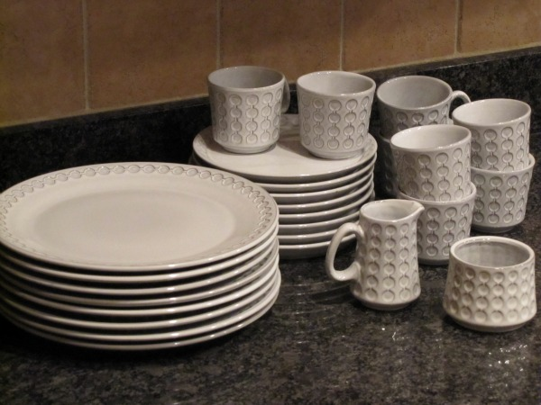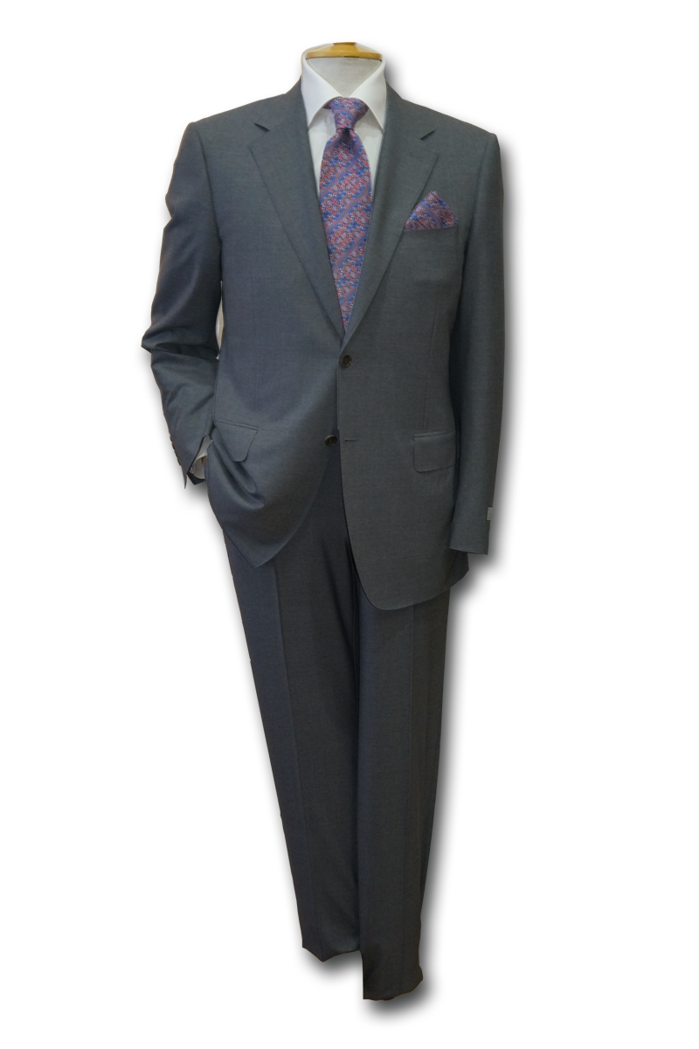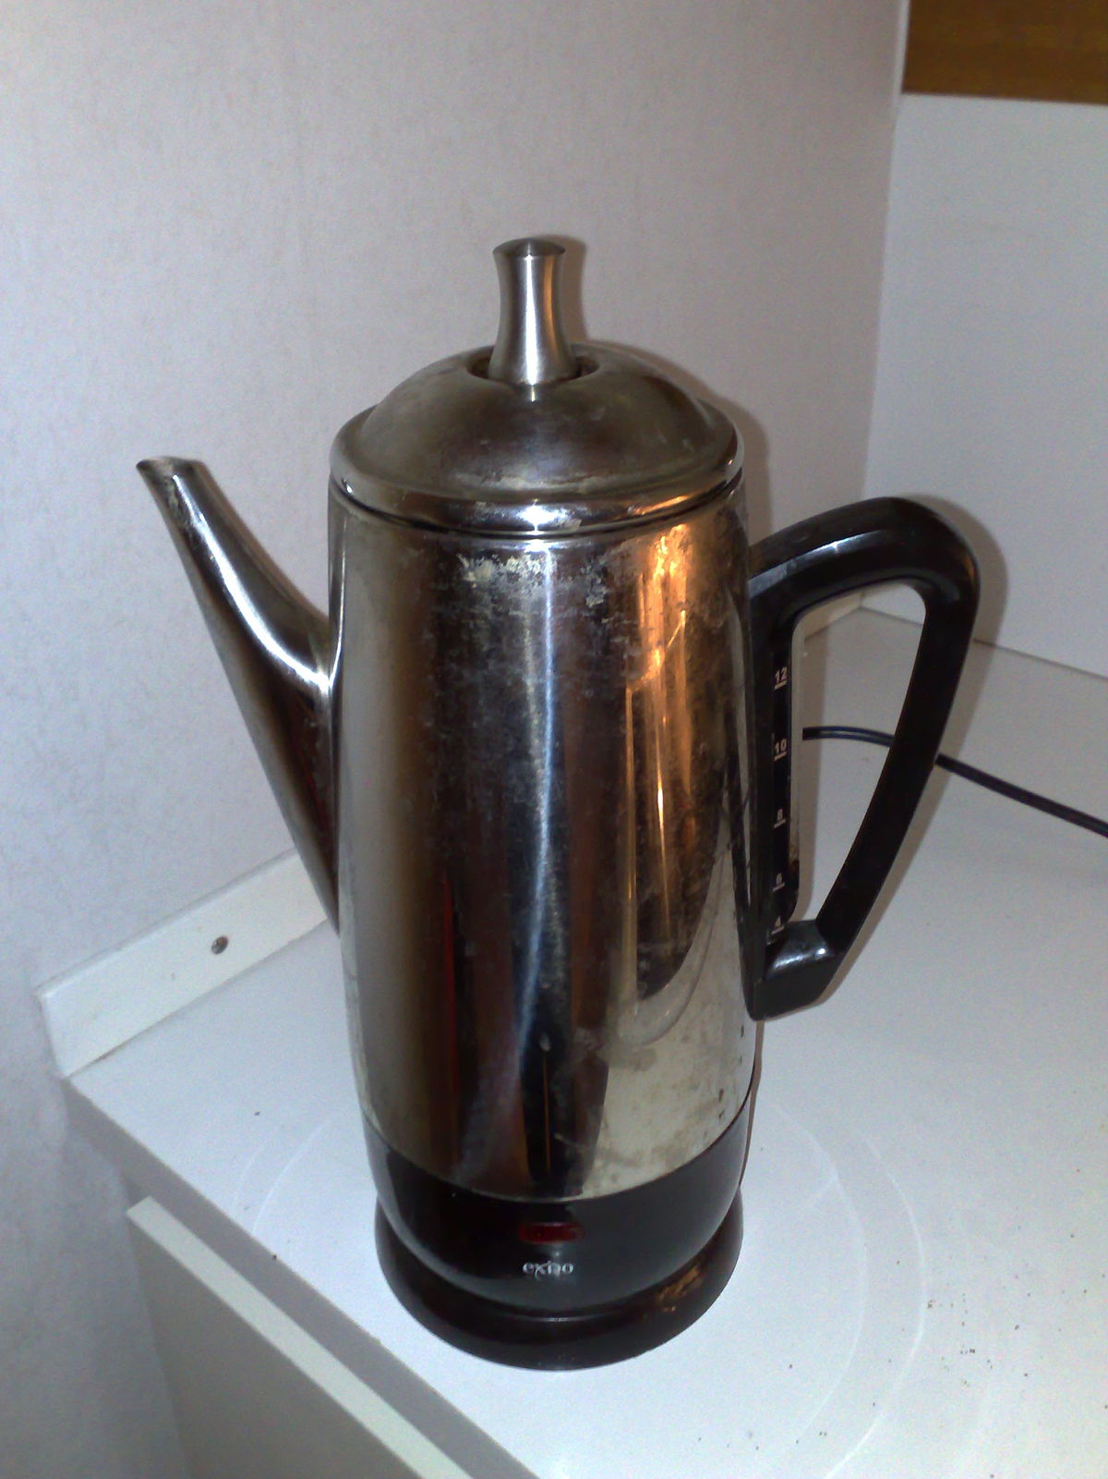
If you have provided your email address to the Department Secretary then it is on file at National and more than likely you were sent a notice by the electronic method.
The dues amount is the same as the previous 2 years, at $40.00 for senior members and $10.00 for Junior members.
The Department Membership Chairman is once again working on several incentives to entice units to encourage members to pay dues early so they reach 100% by the end of December. Membership for 2020 terminates on 12/31/20. National gives a 30-day grace period to pay dues but once the calendar reaches February 1st if a member has not paid, they are considered delinquent until dues are paid. The Membership chair had incentives or benchmarks to reach at certain points once the Renewal notices arrive in the state. Once I get them, I will let you know what they are and when/where they fall on the calendar.

Changes made at 15 August meeting

The members present at the Planning meeting on Saturday 15 August voted to change the time the unit meets for meetings. By unanimous vote, our meetings will now begin at 10 AM at the 202 Central Street NE Ste 140. Olympia, WA. Changes will be made to the Standing Rules and these will be sent to the Department Headquarters for filing.
Rational for change: Two of the unit officers often are called in to work their part time job, thus requiring that they either miss our meeting or they attend our meeting and arrive at the job 60 to 90 minutes late.
The effective date for the Change to the Standing Rules will be our September 19th meeting.
Hopefully we will get to see more members at our meetings with this change.

